Bank Loan Analysis

1. Bank Loan Report

KPI’s:

Total Loan Application

select count(id) as Total_Loan_Application from bank_loan_data



Month to date Loan Application

select count(id) as MTD_Total_Loan_Application from bank_loan_data

where MONTH(issue_date) = 12



Previous Month to date Loan Application

select count(id) as PMTD_Total_Loan_Application from bank_loan_data

where MONTH(issue_date) = 11



Total Funded Amount

select sum(loan_amount) as Total_Fund_Amount from bank_loan_data



Month to Date Total Funded Amount

select sum(loan_amount) as MTD_Total_Funded_Amount from bank_loan_data

where month(issue_date) = 12



Previous Month to Date Total Funded Amount

select sum(loan_amount) as PMTD_Total_Funded_Amount from bank_loan_data

where month(issue_date) = 11

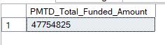

Total Amount Received

select sum(total_payment) as Total_Amount_Received from bank_loan_data



Month to Date Total Amount Received

select sum(total_payment) as MTD_Total_Amount_Received from bank_loan_data

where MONTH(issue_date) = 12

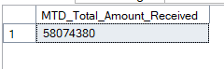

Previous Month to Date Total Amount Received

select sum(total_payment) as PMTD_Total_Amount_Received from bank_loan_data

where MONTH(issue_date) = 11



Average Interest Rate

select avg(int_rate) * 100 as Avg_Interest_Rate from bank_loan_data



Month to Date Average Interest Rate

select avg(int_rate) * 100 as MTD_Avg_Interest_Rate from bank_loan_data

where month(issue_date) = 12



Previous Month to Date Average Interest Rate

select avg(int_rate) * 100 as PMTD_Avg_Interest_Rate from bank_loan_data

where month(issue_date) = 11



Average Debt-to-Income Ratio (DTI)

select avg(dti) * 100 as Avg_DTI from bank_loan_data



Month to Date Average Debt-to-Income Ratio (DTI)

select avg(dti) *100 as MTD_Avg_DTI from bank_loan_data

where month(issue_date) = 12



Previous Month to Date Average Debt-to-Income Ratio (DTI)

select avg(dti) *100 as PMTD_Avg_DTI from bank_loan_data

where month(issue_date) = 11



Good Loan Issued

KPI’s:

Good Loan Percentage

select

(count(case when loan_status = 'Fully Paid' or loan_status = 'Current' then id end)*100)

/

count(id) as Good_Loan_Percentage

from bank_loan_data



Good Loan Applications

select count(id) as Good_Loan_Applications from bank_loan_data

where loan_status = 'Fully Paid' or loan_status = 'Current'



Good Loan Funded Amount

select sum(loan_amount) as Good_Loan_Funded_Amount from bank_loan_data

where loan_status = 'Fully Paid' or loan_status = 'Current'



Good Loan Received Amount

select sum(total_payment) as Good_Loan_Received_Amount from bank_loan_data

where loan_status = 'Fully Paid' or loan_status = 'Current'



Bad Loan Issued

KPI’s:

Bad Loan Percentage

select

(count(case when loan_status = 'Charged Off' then id end) *100.0)

/

count(id) as Bad_Loan_Percentage

from bank_loan_data



Bad Loan Applications

select count(id) as Bad_Loan_Applications from bank_loan_data

where loan_status = 'Charged Off'



Bad Loan Funded Amount

select sum(loan_amount) as Bad_Loan_Funded_Amount from bank_loan_data

where loan_status = 'Charged Off'



Bad Loan Received Amount

select sum(total_payment) as Good_Loan_Received_Amount from bank_loan_data

where loan_status = 'Charged Off'



Loan Status

select

loan_status,

count(id) as Total_Loan_Applications,

sum(total_payment) as Total_Amount_Received,

sum(loan_amount) as Total_Funded_Amount,

avg(int_rate * 100) as Interest_Rate,

avg(dti * 100) as DTI

from

bank_loan_data

group by

loan_status

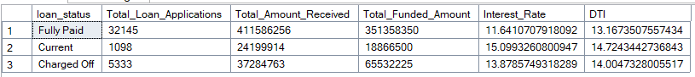

Loan status by Month to Date

SELECT

loan_status,

SUM(total_payment) AS MTD_Total_Amount_Received,

SUM(loan_amount) AS MTD_Total_Funded_Amount

FROM bank_loan_data

WHERE MONTH(issue_date) = 12

GROUP BY loan_status

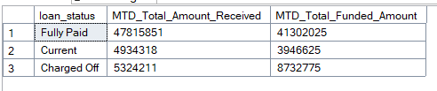

1. **BANK LOAN REPORT OVERVIEW**

Month

SELECT

MONTH(issue_date) AS Month_Munber,

DATENAME(MONTH, issue_date) AS Month_name,

COUNT(id) AS Total_Loan_Applications,

SUM(loan_amount) AS Total_Funded_Amount,

SUM(total_payment) AS Total_Amount_Received

FROM bank_loan_data

GROUP BY MONTH(issue_date), DATENAME(MONTH, issue_date)

ORDER BY MONTH(issue_date)

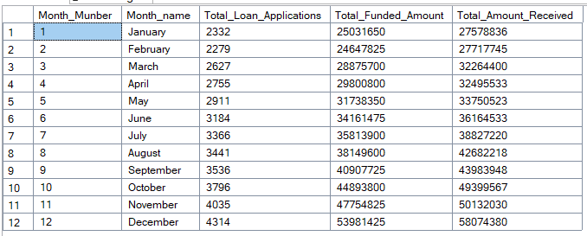

State

SELECT

address_state AS State,

COUNT(id) AS Total_Loan_Applications,

SUM(loan_amount) AS Total_Funded_Amount,

SUM(total_payment) AS Total_Amount_Received

FROM bank_loan_data

GROUP BY address_state

ORDER BY address_state

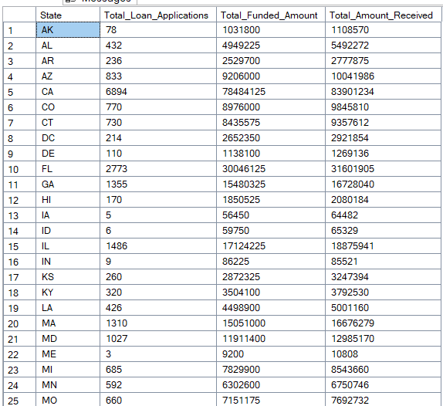

Term

SELECT

term,

COUNT(id) AS Total_Loan_Applications,

SUM(loan_amount) AS Total_Funded_Amount,

SUM(total_payment) AS Total_Amount_Received

FROM bank_loan_data

GROUP BY term

ORDER BY term

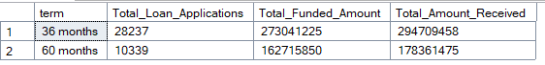

Employee Length

SELECT

emp_length,

COUNT(id) AS Total_Loan_Applications,

SUM(loan_amount) AS Total_Funded_Amount,

SUM(total_payment) AS Total_Amount_Received

FROM bank_loan_data

GROUP BY emp_length

ORDER BY emp_length

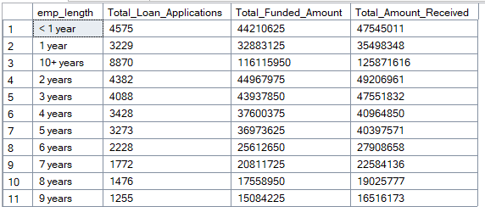

Purpose

SELECT

purpose,

COUNT(id) AS Total_Loan_Applications,

SUM(loan_amount) AS Total_Funded_Amount,

SUM(total_payment) AS Total_Amount_Received

FROM bank_loan_data

GROUP BY purpose

ORDER BY purpose

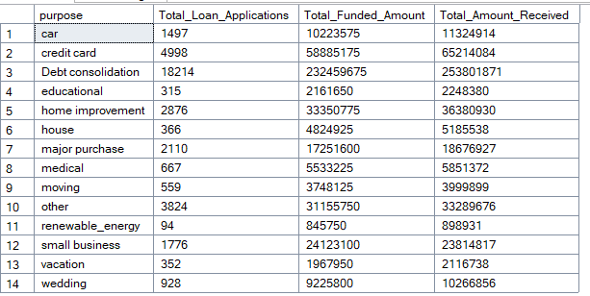

Home Ownership

SELECT

home_ownership,

COUNT(id) AS Total_Loan_Applications,

SUM(loan_amount) AS Total_Funded_Amount,

SUM(total_payment) AS Total_Amount_Received

FROM bank_loan_data

GROUP BY home_ownership

ORDER BY home_ownership

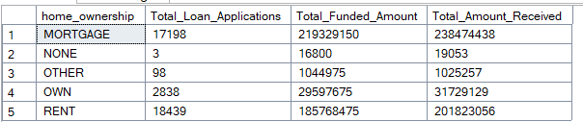

Created By Bhanu Chauhan